I3 digID livescan driver installation instructions for Windows 10 Operating System

*Administrator access to the computer is required when installing the driver.

I3 Livescan Driver Installation Instructions using Google Chrome Browser
- Click on “I3 digID Driver for Windows 10” at https://fadv.com/solutions/fingerprint-background-checks/livescan/
- After i3Installer is downloaded select the up arrow and select Show in Folder.
- Double click i3Installer.zip.
- Right click I3Installer and select Extract… and then select Unzip.
- Double click i3Installer.
- Right click i3Install.bat and select Run as administrator.
- Select Yes at the prompt.
- Press any key to continue…
- Files are installed.
- Close the command window.
- Plug the I3 digID scanner into a USB port and restart the computer

Install the First Advantage – Scanning Component
- Click on “Fingerprint Advantage – Scanning Component at https://fadv.com/solutions/fingerprint-background-checks/livescan/
- After aware-biocomponent.zip is downloaded select the up arrow and select Open.
- Double click aware-biocomponents-fadv exe.
- If you get this message, select Yes.
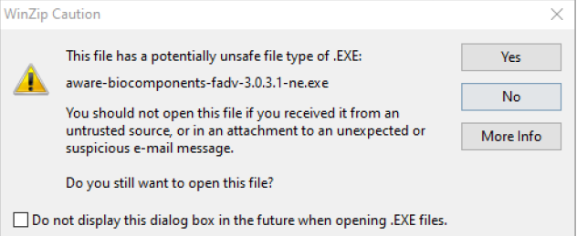
- Select Next
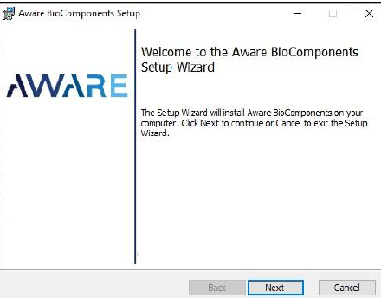
- Check “I accept the terms in the License Agreement” and then select Next.
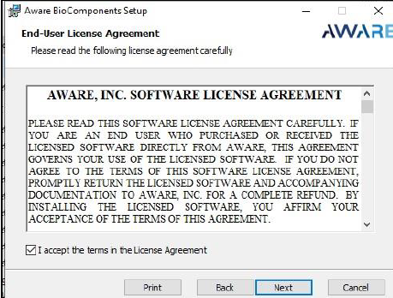
- Select Next.
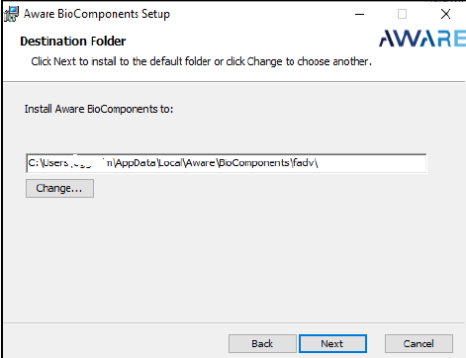
- Click “Finish” to complete the installation.
